Fraud Detection Banking Dataset
  - Exploratory Data Analysis (EDA) and Data Cleaning Using MySQL

Project Overview
The purpose of this project is to analyze and clean a banking fraud detection dataset containing customer, transaction, merchant, device, and fraud-related information. Before performing any analytical tasks, the dataset was assessed for data quality issues such as duplicates, missing values, spelling inconsistencies, blank values, and invalid records.
The cleaning process was performed using MySQL Workbench 8.0 to create a reliable dataset suitable for reporting, dashboard development, and fraud analysis.

Understanding the Dataset
Number of rows: 8,300
Number of columns : 23
Number of rows (after cleaning) : 8000
Number of columns (after cleaning) : 36

Customer Variables
- customer_id
- account_id
- customer_age
- customer_tenure_months
- customer_city
- customer_country
- account_balance

Transaction Variables
- transaction_id
- transaction_datetime
- transaction_amount
- payment_channel
- transactions_last_24h
- transactions_last_30d
- avg_transaction_amount_30d

Device Variables
- device_type
- device_id
- is_new_device

Merchant Variables
- merchant_name
- merchant_category

Fraud Variables
- risk_score
- fraud_flag

1. Database Creation and Dataset Loading
A new database named fraud_detection was created and the transaction dataset was imported into a table called transactions.
SQL Used
CREATE DATABASE fraud_detection_DB;
USE fraud_detection_DB;

2.Created a raw table
Initially import CSV as VARCHAR columns.
CREATE TABLE fraud_transactions_raw (
transaction_id VARCHAR(50),
customer_id VARCHAR(50),
account_id VARCHAR(50),
transaction_datetime VARCHAR(100),
transaction_amount DECIMAL(15,2),
merchant_name VARCHAR(100),
merchant_category VARCHAR(100),
payment_channel VARCHAR(50),
device_type VARCHAR(50),
device_id VARCHAR(100),
ip_address VARCHAR(50),
customer_age VARCHAR(20),
customer_tenure_months INT,
customer_city VARCHAR(100),
customer_country VARCHAR(100),
account_balance DECIMAL(15,2),
failed_transactions_last_24h INT,
transactions_last_24h INT,
transactions_last_30d INT,
avg_transaction_amount_30d DECIMAL(15,2),
distance_from_home_km DECIMAL(15,2),
is_international INT,
is_new_device INT
);
Import the csv file into created table.

Initial Data Exploration
Before cleaning, the dataset structure and volume were examined.
Preview Dataset
SELECT *
FROM transactions
LIMIT 10;
Purpose
To understand the available columns and data format.
Output
- First 10 rows of the dataset
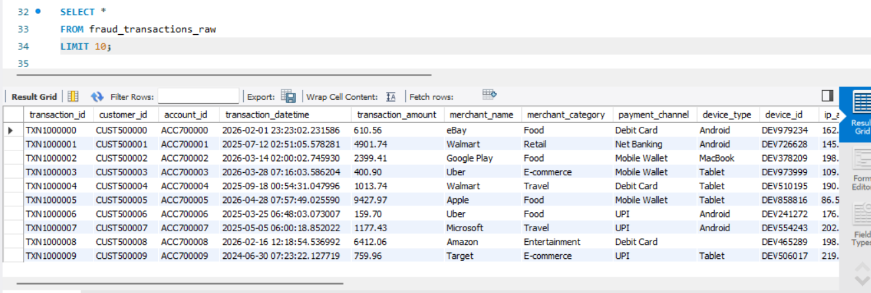

Count Total Records
Purpose
To determine the size of the dataset.
Output
- Total row count result
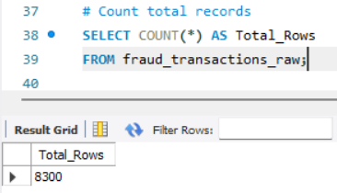

Count Total Columns
Purpose
To identify the number of variables available for analysis.
Output
- Total columns result
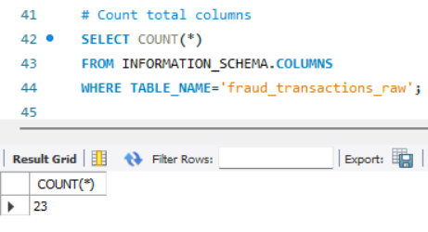

3. Creating a Working Copy
To preserve the original dataset, a duplicate table was created.
SQL Used
CREATE TABLE transactions_clean AS
SELECT *
FROM transactions;
Purpose
Allows cleaning operations without modifying the raw data.

4. Adding a Primary Key
SQL Used
ALTER TABLE transactions_clean
ADD COLUMN row_id INT AUTO_INCREMENT PRIMARY KEY;
Purpose
A unique identifier was added to support duplicate removal and indexing.

5. Duplicate Detection and Removal
Identify Duplicate Records
SELECT transaction_id,
COUNT(*) duplicate_count
FROM transactions_clean
GROUP BY transaction_id
HAVING COUNT(*) > 1;
Findings
Several transaction IDs appeared more than once.
Output
- Duplicate transaction IDs
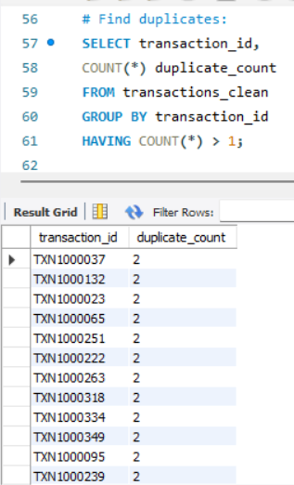

Remove Duplicates
DELETE t1
FROM transactions_clean t1
INNER JOIN transactions_clean t2
ON t1.transaction_id = t2.transaction_id
AND t1.row_id > t2.row_id;
Purpose
Keeps only the first occurrence of each transaction.

6. Correcting Data Entry Errors
Country Name Standardization
Examples:
- Indai, INDIA, india, IND → India
Purpose
Ensures consistency in geographical analysis.

Merchant Name Standardization
Several merchant names contained spelling errors.
Examples:
- Amazn, AMAZON, amazon → Amazon
Purpose
Standardized merchant names improve aggregation accuracy.

Device Name Standardization
Examples:
- Andriod, ANDROID → Android
Purpose
Ensures consistency in technical analysis.

7. Missing and Blank Value Analysis
Identify Blank Values
SELECT *
FROM transactions_clean
WHERE customer_age = ''
OR merchant_name = ''
OR customer_city = ''
OR device_type = '';
Findings
Several fields contained empty strings instead of NULL values.
Output
- Blank value records
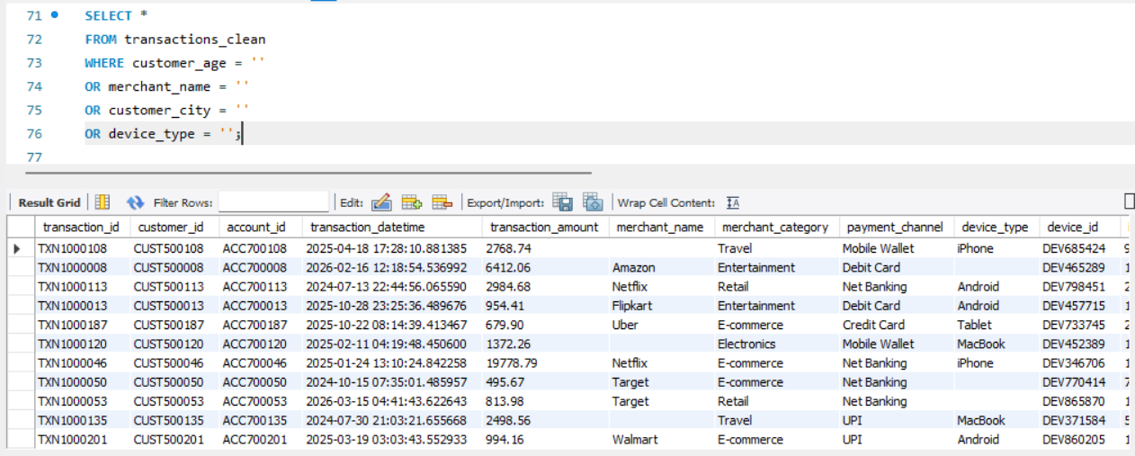

Convert Blank Values to NULL
UPDATE transactions_clean
SET customer_city = NULL
WHERE customer_city = ' ';
Purpose
Creates a standardized representation of missing data.

8. Missing Value Treatment
Numerical Variables
Customer Age
Missing values were replaced using the median because age distributions may contain outliers.
Reason
Median is more robust than mean.

Categorical Variables
Missing values were replaced using the mode (most frequent value).
Variables treated:
- Merchant Name
- Customer City
- Device Type
- Payment Channel
Reason
Mode preserves existing distribution patterns.

Verification
SELECT
SUM(customer_age IS NULL),
SUM(account_balance IS NULL),
SUM(merchant_name IS NULL),
SUM(customer_city IS NULL),
SUM(device_type IS NULL),
SUM(payment_channel IS NULL)
FROM transactions_clean;
Result
No missing values remained after imputation.
Output
- Missing values verification result
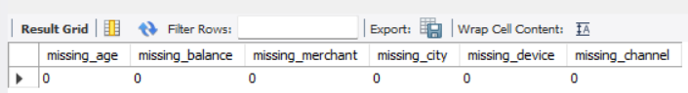

9. Invalid Data Corrections
Negative Transaction Amounts
Detection
SELECT *
FROM transactions_clean
WHERE transaction_amount < 0;
Purpose
Transaction amounts should not be negative in this dataset.

10. Text Standardization
Text fields were cleaned using TRIM().
Variables cleaned:
- merchant_name
- customer_city
- payment_channel
Purpose
Removes unwanted leading and trailing spaces.

11.Invalid age detection
SELECT *
FROM fraud_transactions_raw
WHERE customer_age < 18
OR customer_age > 100;
Purpose
Age should not be less than 0 or greater than 100.

Outlier Detection
SQL Used
SELECT *
FROM transactions_clean
WHERE transaction_amount > 50000;
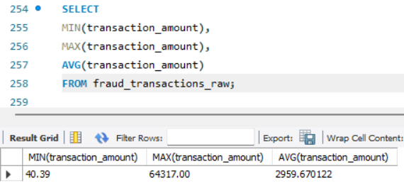
Purpose
Identify unusually large transactions that may indicate fraud.

12. Feature Engineering
The original transaction datetime column was decomposed into separate components.
New Variables Created
- transaction_year
- transaction_month
- transaction_day
Purpose
Facilitates time-based fraud analysis.

13. Performance Optimization
Indexes were created to improve query performance.
Indexed Columns
- transaction_id
- customer_id
- fraud_flag
- merchant_name

14. Final Data Validation
Record Count
SELECT COUNT(*)
FROM transactions_clean;
Purpose
Verify no unintended record loss.
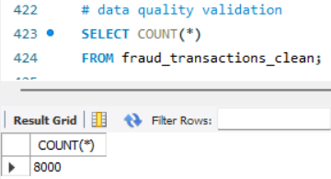

Duplicate Check
SELECT transaction_id,
COUNT(*)
FROM transactions_clean
GROUP BY transaction_id
HAVING COUNT(*) > 1;
Expected Result
No duplicate transactions.

Fraud Distribution
SELECT fraud_flag,
COUNT(*) AS total_transactions
FROM transactions_clean
GROUP BY fraud_flag;
Purpose
Understand class distribution.
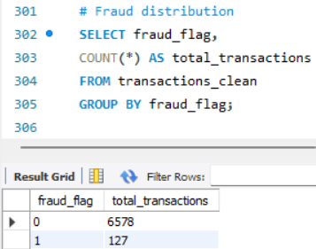

Missing Value Check
SELECT
SUM(customer_age IS NULL),
SUM(account_balance IS NULL),
SUM(device_type IS NULL),
SUM(customer_city IS NULL)
FROM transactions_clean;
Expected Result
All values should equal zero.
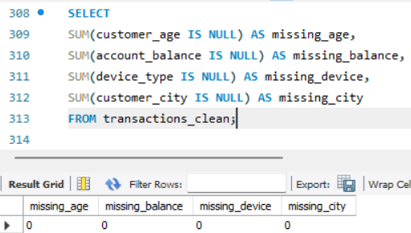

Outlier Summary
SELECT
MIN(transaction_amount),
MAX(transaction_amount),
AVG(transaction_amount)
FROM transactions_clean;
Purpose
Evaluate overall transaction amount distribution.
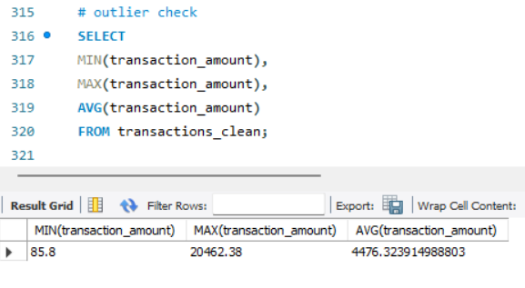

Create Risk Score
Risk scoring is a feature engineering technique used in fraud detection to estimate the likelihood that a transaction is fraudulent. Instead of evaluating multiple indicators separately, they are combined into a single numerical score.
In this project, the risk score is calculated using factors such as:
- Number of failed transactions in the last 24 hours
- Number of transactions performed in the last 24 hours
- International transaction status
- Whether a new device was used
A higher score indicates a higher probability of fraud. Risk scores help banks prioritize investigations and trigger automated fraud alerts.
Business Benefit:
- Faster fraud identification
- Better prioritization of suspicious transactions
- Reduced manual review effort

Create Customer Segment
Customer segmentation divides customers into groups based on shared characteristics. In banking, account balance is commonly used to classify customers into segments such as Premium, Gold, and Regular.
Segmentation helps organizations understand customer value and behavior patterns.
Example:
- Premium Customers → High account balance
- Gold Customers → Medium account balance
- Regular Customers → Lower account balance
Business Benefit:
- Personalized services
- Targeted marketing campaigns
- Better fraud monitoring based on customer profiles

Create Transaction Size Category
Transaction categorization groups transactions into different levels based on transaction amount.
Typical categories include:
- Low Value Transactions
- Medium Value Transactions
- High Value Transactions
Large transactions often require additional monitoring because they may represent higher financial risk.
Business Benefit:
- Simplifies transaction analysis
- Helps identify unusual spending patterns
- Supports fraud detection and reporting

Create Fraud Flags
Fraud flags are labels assigned to transactions based on predefined business rules or risk thresholds. They provide a quick indication of whether a transaction should be reviewed.
For example:
- Low Risk
- Medium Risk
- High Risk
Fraud flags are often generated from risk scores and are used by fraud analysts to focus on suspicious activities.
Business Benefit:
- Quick identification of risky transactions
- Automated fraud screening
- Improved operational efficiency

Index Creation
Indexes are database structures that improve the speed of data retrieval operations. Without indexes, the database must scan the entire table to locate records.
Common columns indexed in fraud datasets include:
- Customer ID
- Transaction ID
- Merchant Name
- Country
- Transaction Date
Indexes significantly improve query performance, especially when dealing with thousands or millions of records.
Business Benefit:
- Faster reporting
- Improved dashboard performance
- Reduced query execution time

Data Quality Validation
Data quality validation is the final verification step performed after cleaning. It ensures that data meets quality standards and is suitable for analysis.
Validation checks typically include:
- Total record count
- Duplicate count
- Missing values
- Unique transaction IDs
- Data consistency
Business Benefit:
- Increased confidence in results
- Prevention of reporting errors
- Higher data accuracy

Create Audit Log Table
An audit log records all data-cleaning and transformation activities performed on the dataset. It provides transparency and traceability for data management processes.
The audit log typically stores:
- Cleaning step performed
- Number of records affected
- Date and time of execution
- User or process responsible
Business Benefit:
- Supports compliance requirements
- Enables troubleshooting
- Improves accountability

Conclusion
The dataset contained several data quality issues including duplicate transactions, missing values, spelling inconsistencies, blank fields, and invalid transaction amounts. These issues were systematically identified and resolved using MySQL. The cleaned dataset is now suitable for exploratory analysis, fraud detection reporting, Power BI dashboard development, and predictive modeling.
The data cleaning process improved data consistency, accuracy, and reliability, ensuring trustworthy analytical results.

